Consultation on Dacorum Local Plan (2020-2038) Emerging Strategy for Growth

Respond by 28 February 2021
Online: https://consult.dacorum.gov.uk/kse
By email to: responses@dacorum.gov.uk
By post to: Strategic Planning, Dacorum Borough Council. The Forum, Marlowes, Hemel Hempstead, Hertfordshire. HP1 1DN
Berkhamsted and Tring Labour Party
Our response to the questions in the consultation
Approved by Berko & Tring Labour Party Branch, 11/02/2021
Question 1: Do you think the overarching vision, the vision for Dacorum’s places and the strategic objectives are right for the Borough?
Climate Change Emergency
The Climate Change Emergency needs to be at the core of the Local Plan. The central thread of the Local Plan should be net zero carbon emissions by 2030 and minimising carbon emissions during any construction.
The Climate Change Emergency is rightly a headline statement in the plan, but there is little follow through in the subsequent detail except ill-defined aims, such as promoting an unquantified reduction in greenhouse gas (“GHG”) emissions.
Overarching Vision: Environmental Sustainability
The promotion of renewable energy as proposed in the plan is insufficient to meet the challenge of the Climate Emergency. To achieve net zero emissions by 2030 all new homes and offices must have maximum insulation, only utilise electrical energy, must have rooftop solar panels installed at the time of construction, and must be fitted with efficient heating such as air source heat pumps. All public transport must be electrified. At construction provision must be made for home electric vehicle chargers and an adequate number of community fast chargers. All power must be supplied by electricity or hydrogen generated from sustainable energy sources.
Overarching Vision: Economic Growth
In addition to the Enviro-Tech aspirations in the plan we wish to see preference given to developments which fit with the likely changes to working patterns in the aftermath of the COVID-19 epidemic. Priority should be given to plans and developments which will support local green business, including green STEM businesses, close-to-home communal office space, green domestic builders & installers to help decarbonise Dacorum, and small businesses selling locally sourced goods.
Berkhamsted & Tring Developments
We welcome the commitment to genuinely affordable housing to be included in developments in Berkhamsted and Tring but believe affordable needs to be properly defined in the plan and must contain an adequate proportion of social housing with rents set at no more than a third of the average income of workers in Dacorum.
The proposals in the plan for infrastructure and employment growth are not sufficient for the number of new dwellings proposed in these market towns.
The plan must guarantee the protection of existing natural habitats and creation of new ones by rewilding. It must ensure that there are migration corridors that connect the green spaces as far as possible to increase biodiversity.
To sustain an increase in population, improvements in infrastructure need to be implemented as houses are built. These are commuter towns and residents rely on transport to make journeys out of the town to travel to work. The present rail and road networks will not sustain such an increase in population.
Question 2: Do you have specific comments about the Sustainable Development Strategy?
Sustainable Development in Dacorum
There are no specific details of the measures proposed to meet the 2030 net zero target. By 2025 the borough needs to be more than halfway there, but without targets there is a high risk that we do not meet the 2030 net zero target and that we compromise “the ability of future generations to meet their own needs” since they will be in Climate Chaos.
Spatial Strategy for Growth
The plan must ensure adequate Social Housing, which is net zero in operation, as defined in our answer to question 1.
The plan must allow for an increase in electrically powered transport and roads must be designed to encourage walking and cycling.
The Settlement Hierarchy
Berkhamsted and Tring are identified in the plan to be sustainable locations. These are ‘commuter towns’ where many residents work out of borough. There are insufficient employment opportunities locally in Tring and Berkhamsted to sustain the proposed growth.
To ensure future sustainability, there will need to be a significant shift to local employment, there are no proposals in the plan to make the necessary employment space available for a change of this scale.
The Housing Strategy
The housing strategy should reflect our vision given in question 1.
The Employment Strategy
Improved local employment opportunities are required in Tring and Berkhamsted to support quality community development and vibrancy. Without local employment the towns’ proposed growth will foster a remote commuter-belt culture.
The Retail and Leisure Development Strategy
Vibrancy of town centres should consider the current trends exacerbated with COVID-19. There has been a huge shift to shopping online for mass-produced goods and physical banking has reduced significantly. The strategy must ensure the protection of local leisure facilities, pubs, bars and restaurants and shops.
Priority should be given to plans and developments which will support local green business, including green STEM businesses, close-to-home communal office space, green domestic builders & installers to help decarbonise Dacorum, and small businesses selling locally sourced goods.
Delivering the Infrastructure to Support Growth
The plan must ensure that the necessary increase in infrastructure is powered electrically and the electricity demand met by sustainable sources (renewable energy).
Plans must promote green mobility: Home and public electric vehicle charge points, cycle paths and developers to contribute to the development of reliable electric local bus network with strengthened grid supply to support it.
Question 3: Do you have specific comments about any of the Guiding Development policies?
Housing Delivery: Affordable Housing
Affordability is ill defined in the plan. If it is proposed that the current government guidance of 80% of market value is used, the majority of local people working in the borough are ruled out of being able to purchase a house.
Genuinely affordable should mean the rent or level of mortgage repayment is no more than a third of the household income, this must be calculated on the income of workers in Dacorum, not London, where average salaries are higher.
Employment Development
There should be a designated Article 4 area covering Berkhamsted and Tring town centres, to require planning applications for changes of use from offices to housing. Further loss of town centres offices should not be approved unless a strong case is demonstrated, as there is a deficit of offices predicted in both areas and the Borough generally.
Retailing and Other Town Centre Uses
There should be protection for public houses written into the local plan. Applications for the change of use, redevelopment and/or demolition of a public house should have to demonstrate that:
(i) the public house use is no longer economically viable; a viability report must be submitted, and this must include evidence of active and appropriate marketing over a continuous period of at least 12 months and evidence that all reasonable efforts have been made to preserve the facility;
(ii) the proposal would not result in the loss of a service or facility of value to the local community; and
(iii) community ownership should be preferred to change of use/redevelopment and/or demolition.
Climate Change and Sustainability
The plan should be much more ambitious in its goals and focus on Climate Change and Sustainability.
Dacorum declared Climate Emergency in April 2019 and has committed to reducing carbon emissions across Council activities to net zero by 2030. The policies and plans for growth must represent net zero carbon emissions.
All construction must be carbon neutral from development to finished build. Please see some examples already in the UK: https://goodhomes.org.uk/net-zero-map.
We welcome the plans for reducing building power demand in the form of high insulation levels and building orientation but please also see our response to Environmental Sustainability in question 1.
Environment and Biodiversity
New developments should ensure an increase in natural habitats (rewilding), connected with green corridors to neighbouring wild natural habitats.
Designs which include green infrastructures in developments should be preferred, such as green walls, beehives, reed beds, green roofs, hedgerows, wildlife overpasses. See below from European Environment Agency.

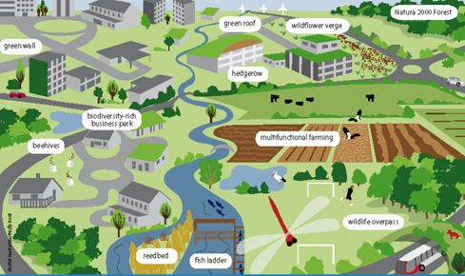
https://www.eea.europa.eu/themes/sustainability-transitions/urban-environment/urban-green-infrastructure/what-is-green-infrastructure
The procurement process should have a bidders prequalification phase with an environmental impact assessment demonstrating how bidders propose to protect natural habitats, improve quality of the overall environment: land, water and air as well as contributing to biodiversity. Mitigation should include a detailed plan on how to achieve zero emissions and carbon footprint.
The plan should also guarantee the following:
- Green belt land to only be released in phases, with a date contractually agreed with developers to begin work to both allow a change in strategy if house demand decreases and also to ensure developers do not bank land to inflate prices.
- Where there is a reasonable likelihood of the presence of statutorily protected species or their habitats, development should not be permitted.
- All major developments must be required to deliver an overall net gain in biodiversity of 15%, determined by applying the Natural England Biodiversity Metric 2.0 Calculator.

- Air Quality Management Areas (AQMAs) should be introduced in each High Street Town in Dacorum with new developments to monitor decrease in pollution.

- Control of polluted waters discharge to non-mains drainage prohibited.

- Developments must be designed to ensure the lowest possible light pollution and utilise low energy lights.

- Tree protection: Arboriculture Impact Assessment (AIA) including a tree survey identifying existing trees on and adjoining the site with their root protection areas (RPA); where tree protection measures are necessary, a Tree Protection Plan (TPP); and an Arboriculture Method Statement (AMS) that identifies how operations can be undertaken with minimal harm to retained trees.

- Integrate planting with the existing green infrastructure network, native broad-leaved species, and avoiding the use of invasive, non-native species; provide irrigation infrastructure and mature trees (>6years old).

- If villages are developed, the plan should guarantee a land reclaim for rewilding commercial forestry land or its equivalent.

- Priority must be given to the redevelopment of brownfield land, whether redundant or in continuing use (excluding temporary buildings).
Delivering Great Places
Taller buildings should be prioritised over releasing areas of green belt land when aiming to meet house building targets.
There should be a programme to actively identify non-designated heritage assets during the period of the local plan.
In assessing all developments there needs to be consideration given to the impact of traffic on schools and existing residential areas. If the construction or the finished development will cause significant congestion in the area of a school, it should not be approved.
Sustainable Transport and Connectivity
All residential developments of 15 units and above must be required to contribute towards the creation or improvement of electrified bus transport to the local key destinations.
All residential developments of 30 units and above must create safe cycling routes and must be required to install publicly accessible bikes and electric vehicle fast charge points.
Permission for larger developments must be conditional on the prior completion of the necessary infrastructure projects to keep with the pace of development and ensure sustainability for existing and new residents and businesses.
Healthy Communities
Health Impact Assessments should be required in all residential developments of 25 units and above.
All new residential development above 20 units must be required to contribute towards additional leisure facilities provision. These should be calculated using Sport England's Sport Facility Calculator.
Developers must be required to make appropriate contributions to new health care provision to support residents in accordance with the Council's Infrastructure Delivery Plan as a condition of agreeing permission for the development.
Question 4: Do you have specific comments about any of the Delivery Strategies?
The strategy for Berkhamsted and Tring relies too heavily on developing expensive two storey dwellings rather than more affordable higher storey properties on brownfield sites.
The reliance on speculative developers to carry out this work will do nothing to ensure the affordability of housing, the plan does not protect against the risk that property prices will be artificially inflated by developers banking land, and/or building properties which are unaffordable to people who work locally.
This plan will create housing but will destroy great swathes of countryside. Properties will not be affordable to people working locally and the developments will draw in new commuter residents. The plan will not solve the housing shortage experienced by local residents and workers.
The number of dwellings proposed exceeds that which is sustainable for the combined capacity of the market towns of Berkhamsted and Tring. The infrastructure of these two areas is interlined and interconnected. In terms of transport, their High Roads are linked by the main routes between the towns and the main arteries into the towns. They both also rely on the A41, the same train line and shopping facilities. There is no local hospital between the two towns. The two towns share the same bus routes. The delivery strategy takes no account of the combined pressure on the infrastructure which would be created by the combination of the proposed large house building projects in both Berkhamsted and Tring.
The main Berkhamsted developments are at the edge of town. As Berkhamsted is in a valley, most residents in those developments will need to use private passenger vehicles to travel into town and in order to connect with public transport hubs. The proposals in these locations are for family homes and retirement properties. It is not practical or realistic to expect families or elderly residents to travel by foot or bicycle from these developments. Furthermore, the routes into town and to the railway station from the proposed sites are through narrow residential roads with on-street parking. The proposed sites will cause immense congestion on those roads, increasing pollution and hazards to pedestrians.
In the case of Tring, the amount of housing and the potential area affected is very significant and includes the addition of 2,731 new houses, 1 new secondary school, 2 new primary schools, and associated retail, sport and industrial developments – almost doubling the size of the town. This equates to a 55% increase in houses for Tring, mostly on Green Belt land.
The proposed developments on the Green Belt, particularly in East Tring, are not connected with services or the town and will therefore have a considerable impact on the environment, air quality and GHG emissions.

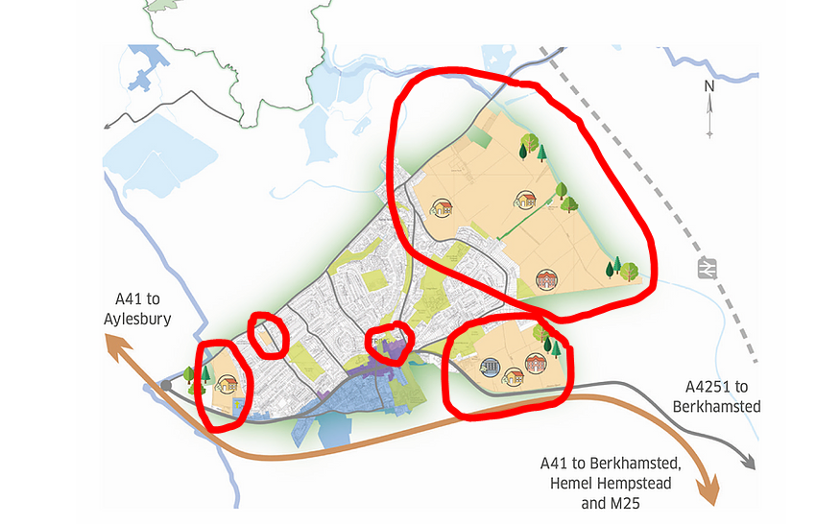

Question 5: Do you have specific comments about any of the Proposals and Sites?
Yes, already explained in Question 4.
Question 6: Do you have any comments on the Sustainability Appraisal (SA) that accompanies the Plan?
As stated in the Sustainability Appraisal: “any development that takes place on greenfield sites, including that in areas currently in the Green Belt has the potential for adverse effects … relating to habitat loss, increased water consumption, impacts on local landscapes, soil sealing, natural resource use, increased waste, and increased emissions of both greenhouse gases and airborne pollutants”
Many of the proposed development sites are NOT close to facilities and services and are NOT well connected by transport infrastructure
There is no comprehensive calculation in the plan or the SA on what is affordable in comparison to minimum wage and average wages in Dacorum.
Biodiversity (SA Objective 1)
Policies in the Local Plan should concentrate on housing and employment development in urban areas and away from greenfield sites to protect, maintain and enhance designated sites and their buffer zones and reduce the loss of agricultural land which may have biodiversity value. This laudable aim is not followed through in the selection of the proposed development sites in Berkhamsted and Tring, which include greenfield and agricultural land.
Net-gain for biodiversity should mean gains through the integration of green infrastructure into the new developments, protection of natural habitats in the new areas of development and a return of natural ecosystems by rewilding and connection of habitats.
Flood Risk (SA Objective 3)
SA states it has found ‘no predicted effects’ against this objective because the level of growth proposed in the Local Plan should be provided without the need to develop in areas of higher flood risk. However, the largest area of development in Tring, between Bulbourne Road and Station road, floods regularly (please see picture below taken in January 2021).
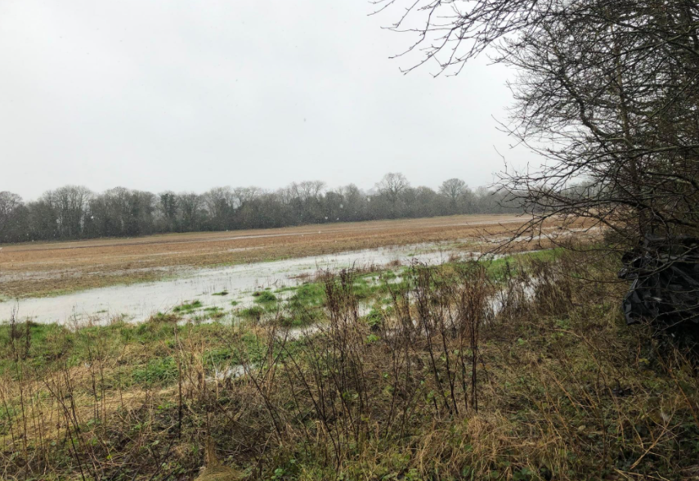
Photo of area for development taken by a local resident (no copyright)
Greenhouse gas emissions (SA Objective 4)
The provision of 16,596 new homes and 116,500 sqm of industrial floorspace requires a detailed plan to reduce GHG emissions. This must contain the relevant data/evidence base and include planning for robust electric public transportation, zero emission construction and absorbing carbon dioxide from the atmosphere by tree planting (fixation).
Air Quality (SA Objective 5)
Transport is a key source of air pollution and so inevitably making provision for 16,596 new homes and 116,500 sqm of industrial floorspace over the Local Plan period will contribute to background emissions through an increase in the number of vehicles on the road.
The plan needs to provide a comprehensive data analysis on the negative impact on air quality. The outcome of such analysis should inform a plan which ensures the reduction of air pollution via:
- the selection of development sites which do not encourage car use or increase congestion;
- the creation of a robust electric transport network;
- planning which ensures net zero emissions from new developments; and
- the creation of carbon fixation via rewilding and protection of natural habitats.
Landscape & Townscape (SA Objective 9)
The SA and Plan sites an ambition to concentrate most of the development in the Borough’s most sustainable settlements to reduce the amount of greenfield land required to deliver growth, thereby reducing levels of adverse effects on local landscapes. The aim is laudable but not carried through in the proposed development of Berkhamsted and Tring, in terms of, design and site selection.
Housing (SA Objective 13)
Significant positive effects have been predicted against this objective as the plan requires the provision of 16,595 homes across the plan period. This meets the Borough’s Objectively Assessed Need (OAN) and includes a mix of housing tenures, types and sizes of home (a minimum of 35% to be affordable housing), however, affordable needs to be defined and must be based on the income of people working in Dacorum.
The percentage of affordable housing must be higher to solve the problem of the housing shortage for local people. By prioritising the development of truly affordable homes fewer houses will be required overall to solve the housing shortage, and there will be less pressure to build on the greenfield sites.
Question 7: Do you agree that the Evidence Base that accompanies the Plan is adequate, up to-date and relevant?
The consultation period should be extended to allow the documentation that is either in draft or not delivered to be published:
- Climate Change and Sustainability SPD,
- Detailed Design Guide SPD
- Climate Change Strategy and Action Plan
- Final version of Strategic Design Guide SPD- as this specifies details and the criteria for the Sustainability Statements to guide developers

Question 8: Do you think the Plan is consistent with the National Planning Policy Framework (NPPF) and supporting guidance?
- Para 11(b) of the NPFF requires ‘objectively assessed needs for housing’. The number of houses should specifically meet Dacorum’s need for the full range of affordable social housing, as defined in our answer to question 1.
- The plan has failed to take account of Para 11, footnote 6 of the NPFF which allows local authorities to restrict the scale of development due to other planning constraints including impacts on the Green Belt and AONB.
- Para 20(c) of the NPFF requires ‘sufficient provision for community facilities (such as health)’ there appears to have been no assessment of the impact on capacity of existing primary care provision, nor time-scaled provision for additional primary healthcare facilities to bridge the gap.
- NPFF requires development on Green Belt land achieves net environmental gain and is mitigated by compensating development of surrounding natural spaces, there is no evidence that this has been adequately considered.
The proposed wildlife corridors are not explicit or mapped as required by the NPPF.

Question 9: Do you have any other comments on the Plan?

No

